EMILIA SERRANO DECENA

W E B D E V E L O P E R

# CONTACTO

[emiliaserrano2814@gmail.com](mailto:emiliaserrano2814@gmail.com) Cel: 809-674-3706

https://[www.linkedin.com/in/e](http://www.linkedin.com/in/e) milia-serrano-225263223/

santo domingo norte, dominican republic

# FORMACIÓN ACADÉMICA

Autonomous University of Santo Domingo, Education 2022

Excellence Center, 2018

**ABOUT**

I am intelligent, i consider myself a capable person, willing to take on new challenges, i quickly capture the assignments or tasks given.

Web Developer

I am a web developer, with my knowledge I have been able to make some web pages, cards with bootstrap, gallery, among other things.

I identify myself with teamwork, with good human relations and performance in the area that touches my work, I feel capable enough to take on great challenges, improve and learn new skills.

**Skills**

percentage of my skills in web development.

Bachelor Jose Francisco School, 2014

# LANGUAJES

* language, technical english language, native Spanish

HTML 90%

CSS 90%

JAVASCRIPT 75%

GIT 80%

GIT HUB 80%

BOOTSTRAP 75%

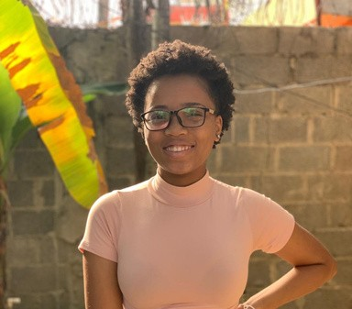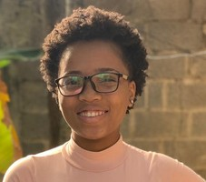

**REFERENCE**

LUIS MAGALLANES (829) 286-7606

ALEJANDRO SANTOS (809) 417-3775